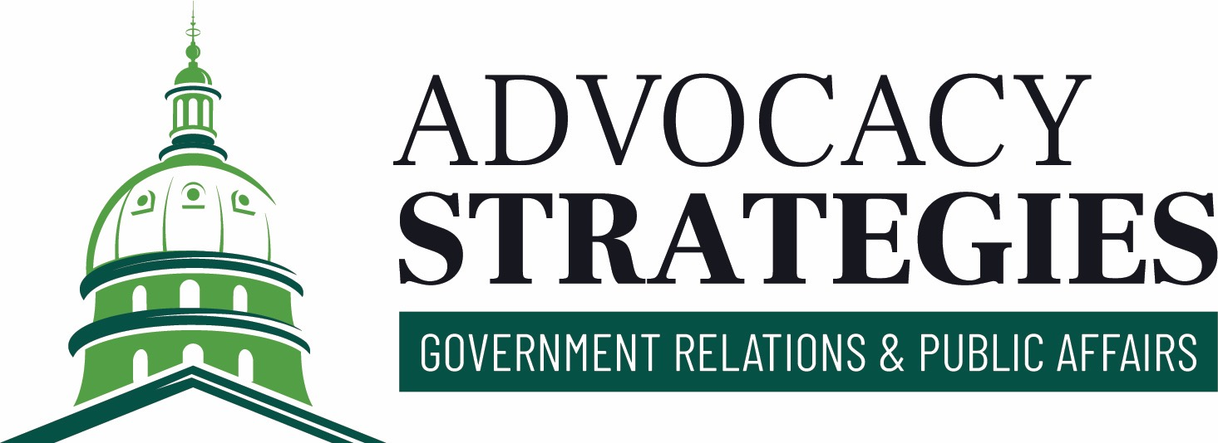

**Priority Legislation**

| **BILL** | **DESCRIPTION** | **STATUS** | **NOTE** |
| --- | --- | --- | --- |
| [HF 93](https://www.legis.iowa.gov/legislation/BillBook?ga=90&ba=HF93) | A bill for an act prohibiting specified provisions in agreements between employers and certain mental health professionals and including effective date provisions. (Formerly HSB 8.) Effective date: 06/01/2023. | Signed by Governor. (6/1/23) Passed House, yeas 95, nays 0. (1/26/23) Passed Senate, yeas 49, nays 0. (4/24/23) | Support/For |

**Signed by the Governor**

| **BILL** | **DESCRIPTION** | **STATUS** | **NOTE** |
| --- | --- | --- | --- |
| [HF 93](https://www.legis.iowa.gov/legislation/BillBook?ga=90&ba=HF93) | A bill for an act prohibiting specified provisions in agreements between employers and certain mental health professionals and including effective date provisions. (Formerly HSB 8.) Effective date: 06/01/2023. | Signed by Governor. (6/1/23) Passed House, yeas 95, nays 0. (1/26/23) Passed Senate, yeas 49, nays 0. (4/24/23) | Support/For |
| [HF 671](https://www.legis.iowa.gov/legislation/BillBook?ga=90&ba=HF671) | A bill for an act establishing the professional counselors licensure compact. (Formerly HF 494, HF 90.) Effective date: 07/01/2023. | Signed by Governor. (6/1/23) Passed House, yeas 98, nays 0. (4/11/23) Passed Senate, yeas 49, nays 0. (4/24/23) |  |
| [SF 561](https://www.legis.iowa.gov/legislation/BillBook?ga=90&ba=SF561) | A bill for an act relating to appropriations for veterans and health and human services and including other related provisions and appropriations including health policy oversight, public assistance program provisions and a public assistance modernization fund, sprinkler systems for home and community-based services waiver recipient residences, a state-funded family medicine obstetrics fellowship program and fund, adoption subsidy program nonrecurring adoption expenses, real estate transactions involving departmental institutions, providing penalties, and including effective date and other applicability date provisions. (Formerly SSB 1213.) Effective date: 06/01/2023, 07/01/2023. | Signed by Governor. (6/1/23) Passed Senate, yeas 32, nays 16. (4/27/23) Passed House, yeas 63, nays 32. (5/2/23) Passed Senate, yeas 32, nays 16. (5/3/23) |  |

**Did Not Advance**

| **BILL** | **DESCRIPTION** | **STATUS** | **NOTE** |
| --- | --- | --- | --- |
| [HF 24](https://www.legis.iowa.gov/legislation/BillBook?ga=90&ba=HF24)  [CO:SF 244](https://www.legis.iowa.gov/legislation/BillBook?ga=90&ba=SF244) | A bill for an act adopting the psychology interjurisdictional compact. | Tabled until future meeting. Vote Total: 3-0. (1/25/23) | Track (no public position, but follow it) |
| [HF 31](https://www.legis.iowa.gov/legislation/BillBook?ga=90&ba=HF31) | A bill for an act prohibiting employers from entering into noncompete agreements with employees under specified circumstances, and including applicability provisions. | Introduced, referred to Labor and Workforce. (1/12/23) | Amend (include details of suggested amendment) |
| [HF 151](https://www.legis.iowa.gov/legislation/BillBook?ga=90&ba=HF151) | A bill for an act relating to the establishment of a mental health practitioner loan repayment program, and providing appropriations.(Formerly HSB 9.) | Subcommittee Meeting: 02/08/2023 12:30PM RM 103, Sup. Ct. Chamber. (2/3/23) |  |
| [HF 273](https://www.legis.iowa.gov/legislation/BillBook?ga=90&ba=HF273)  [CO:SF 210](https://www.legis.iowa.gov/legislation/BillBook?ga=90&ba=SF210) | A bill for an act relating to the term brain health.(Formerly HSB 76.) | Rereferred to Health and Human Services. (5/4/23) |  |
| [HSB 47](https://www.legis.iowa.gov/legislation/BillBook?ga=90&ba=HSB47) | A bill for an act relating to loan repayments made by the college student aid commission under the mental health professional loan repayment program and including applicability provisions. | Committee report, recommending passage. (2/7/23) | 1-30: This bill passed unanimously through subcommittee. Rep. Cahill raised the question of why a bill similar to this one was not passed. The response was that the representatives wanted Iowans to stay and practice in Iowa, and not receive the loan repayment if they left. "A contract is a contract." |
| [SF 210](https://www.legis.iowa.gov/legislation/BillBook?ga=90&ba=SF210)  [CO:HF 273](https://www.legis.iowa.gov/legislation/BillBook?ga=90&ba=HF273) | A bill for an act relating to the term brain health.(Formerly SSB 1078.) | Referred to Health and Human Services. (6/5/23) |  |
| [SF 244](https://www.legis.iowa.gov/legislation/BillBook?ga=90&ba=SF244)  [CO:HF 24](https://www.legis.iowa.gov/legislation/BillBook?ga=90&ba=HF24) | A bill for an act adopting the psychology interjurisdictional compact. | Subcommittee: Costello, Garrett, and Trone Garriott. (2/14/23) | Track (no public position, but follow it) |
| [SF 300](https://www.legis.iowa.gov/legislation/BillBook?ga=90&ba=SF300) | A bill for an act relating to professional disciplinary actions against persons in health-related professions. | Subcommittee recommends passage. []. (2/21/23) |  |
| [SSB 1045](https://www.legis.iowa.gov/legislation/BillBook?ga=90&ba=SSB1045) | A bill for an act relating to professionals who qualify as mental health professionals in certain circumstances. | Tabled until future meeting. []. (1/24/23) | 1/24: after the bill died in the subcommittee, we talked to the staff and the republican members of the cmte. They are finding it difficult to move the bill since the entire MH and medical community is opposed. They had an idea to find all the code sections that reference back to IA Code 228, there are 10 or so. The issue is not section 228, its the one that refer to code 228. Once we find out which ones apply and which ones don't, we can adjust the langauge and come another bill. Expect this one to die and a new one to be introduced. Know we are still working on the issue. |
| [SSB 1100](https://www.legis.iowa.gov/legislation/BillBook?ga=90&ba=SSB1100) | A bill for an act relating to prior authorization exemptions for certain health care providers for specific health care services. | Subcommittee Meeting: 02/08/2023 4:00PM Room 315. (2/8/23) | Like the House’s subcommittee, insurance lobbyists lined up to speak against this bill. Representation from Wellmark suggested that if lawmakers are set on continuing this discussion, they should change the bill to direct health carriers to implement a prior authorization gold card system. He said this shouldn’t be a one-size fits all approach and the carrier should have the ability to craft its own gold card program. “Eliminating prior auth isn’t in the patient’s interest… this is a safety issue.” |
| [SSB 1106](https://www.legis.iowa.gov/legislation/BillBook?ga=90&ba=SSB1106) | A bill for an act prohibiting employers from requiring certain mental health professionals to enter into noncompete agreements and including effective date provisions. | Subcommittee: Garrett, Rowley, and Trone Garriott. (1/31/23) | Support/For |